Custom project progress/final report

COS30017 Software Development for Mobile Devices 2023

Huy Vu Tran

104177995

Table of Contents

Overview of project 1

Weekly reports 1

Week 7 2

Week 8 2

Week 9 2

Week 10 2

Week 11 2

Level 1: Design evidence 3

Level 2: App evidence 4

Level 3: Extended research evidence 7

# Overview of project

The Fitness Tracker App is designed to help users monitor and manage their exercise routines effectively. This app enables users to log their exercise activities, providing a comprehensive way to track fitness progress over time. Users can input details such as the date, duration, and type of exercise for each activity. The app supports creating, editing, and deleting activities, ensuring that users can maintain accurate and up-to-date records of their fitness journey.

# Weekly reports

This is a weekly reflection task for those undertaking custom apps. You are welcome to type or make a video or audio response.

Please note that at least three satisfactory progress reports between weeks 7-11 are required to be eligible for a distinction or higher.

It is the same set of prompts every week:

* What did you achieve this week?
* What are you planning for next week?
* What roadblocks are you facing that we can help with?

## Week 7

* **What did you achieve this week?**

This week, I made significant progress on the custom app design project in Figma. I focused on refining the user interface elements, ensuring that every component aligns with the overall design language. Specifically, I completed the layout for the main dashboard, which now features a clean and intuitive design. Additionally, I finalized the color scheme and typography, ensuring consistency across all screens.

* **What are you planning for next week?**

Next week, I plan to transition from the design phase to the initial coding phase. This will involve starting to implement the primary features of the app, collaborating closely with the development aspects. My goal is to begin coding the main dashboard and core functionalities, ensuring that the design elements I've created can be effectively translated into a functional application. I also aim to continue gathering feedback on my design as I move forward, making any necessary adjustments to ensure the best possible user experience.

* **What roadblocks are you facing that we can help with?**

One of the primary challenges I am currently facing is uncertainty about whether my design is fully optimized for the custom application. While I have put considerable effort into refining the UI and incorporating feedback, I still have concerns about its overall effectiveness and user satisfaction. I would greatly appreciate any additional feedback or insights that could help me validate and improve my design. Additionally, ensuring alignment with development capabilities remains a critical point, and any guidance on potential technical constraints would be beneficial.

## Week 8

* **What did you achieve this week?**

This week, I primarily focused on translating the design created in Figma into XML layouts. This involved meticulously crafting the user interface elements to match the design specifications. Additionally, I began coding the "Add Exercise" function, which allows users to input details such as exercise type, duration, and time.

* **What are you planning for next week?**

Next week, I plan to continue developing the core functionalities of the app. This includes completing the "Add Exercise" function and starting to implement the features for editing and deleting exercise entries.

* **What roadblocks are you facing that we can help with?**

Currently, I am facing some challenges in ensuring that the XML design exactly matches the Figma design, particularly with maintaining consistency across different screen sizes. Additionally, I am uncertain about whether my implementation of the "Add Exercise" function is the most efficient and user-friendly approach. Any guidance or feedback on these aspects would be greatly appreciated.

## Week 9

* **What did you achieve this week?**

This week, I finalized the "Add Exercise" function, ensuring that users can seamlessly input exercise details such as type, duration, and time. Additionally, I developed and implemented the functions for deleting and editing exercise entries, allowing users to manage their exercise logs effectively.

* **What are you planning for next week?**

Next week, I plan to focus on integrating the database to ensure all exercise data is persistently stored and retrieved correctly when the app is opened. I also aim to conduct thorough testing of the add, edit, and delete functions to identify and fix any bugs or usability issues. Furthermore, I will start working on the user interface enhancements to improve the overall user experience.

* **What roadblocks are you facing that we can help with?**

Currently, I am facing some challenges with ensuring the robustness of the edit and delete functions, particularly in handling edge cases and maintaining data integrity. Additionally, I could use some advice on the best practices for database integration to ensure efficient and secure data handling. Any guidance or feedback on these areas would be greatly appreciated.

## Week 10

* **What did you achieve this week?**

This week, I implemented Firebase Firestore as the database for my project. I made necessary changes to the add, update, and delete functions to ensure that any modifications are reflected in the database. Additionally, I updated the MainActivity to display the exercise entries, ensuring that any changes made are dynamically updated and retrieved from Firestore.

* **What are you planning for next week?**

Next week, I plan to focus on optimizing the data retrieval and display processes to ensure smooth and efficient interactions with the database. I will also work on enhancing the user interface to make it more intuitive and user-friendly. Furthermore, I aim to make some necessary improvements for my projects based on the teacher’s feedback.

* **What roadblocks are you facing that we can help with?**

Currently, I am facing challenges with ensuring real-time synchronization between the local app data and Firestore, particularly handling offline scenarios and data consistency. Additionally, I need guidance on best practices for optimizing Firestore queries to enhance performance. Any assistance or feedback on these issues would be greatly appreciated.

## Week 11

* **What did you achieve this week?**

This week, based on feedback from the teacher, I added two new modules to my project. The first module allows users to view and modify their profiles. Users can now set and update their name, occupation, age, height, weight, and picture, with all this data being uploaded to the database. The second module introduces recommended workout plans for users, categorized into three levels: Beginner, Intermediate, and Advanced. Each level contains a set of exercises tailored to that level, along with the estimated time required to complete those exercises.

* **What are you planning for next week?**

Next week, I plan to focus on thoroughly testing the new profile and workout plan modules to ensure they function correctly and provide a smooth user experience. I will also work on integrating these modules seamlessly with the existing features of the app. Additionally, I aim to enhance the user interface for these new features to make them more intuitive and visually appealing. Finally, I will begin gathering user feedback to identify any areas for improvement and further refine the app.

* **What roadblocks are you facing that we can help with?**

Currently, I am facing some challenges with optimizing the database interactions for the new profile and workout plan modules, particularly ensuring efficient data retrieval and updating without compromising app performance. Additionally, I need guidance on best practices for designing a user-friendly interface for these new features. Any assistance or feedback on these issues would be greatly appreciated.

# Level 1: Design evidence (<https://www.figma.com/design/zXFSkZfTGVjzRdpte6v4OS/CUSTOM-APP?node-id=0-1&t=Wdo2cMCCwlf0mqiy-0>)

# Level 2: App evidence

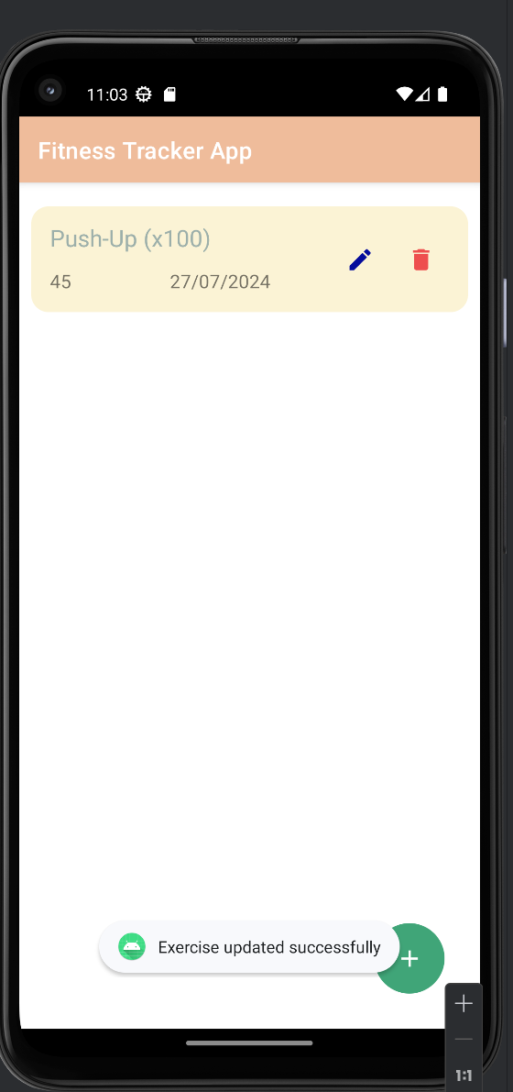 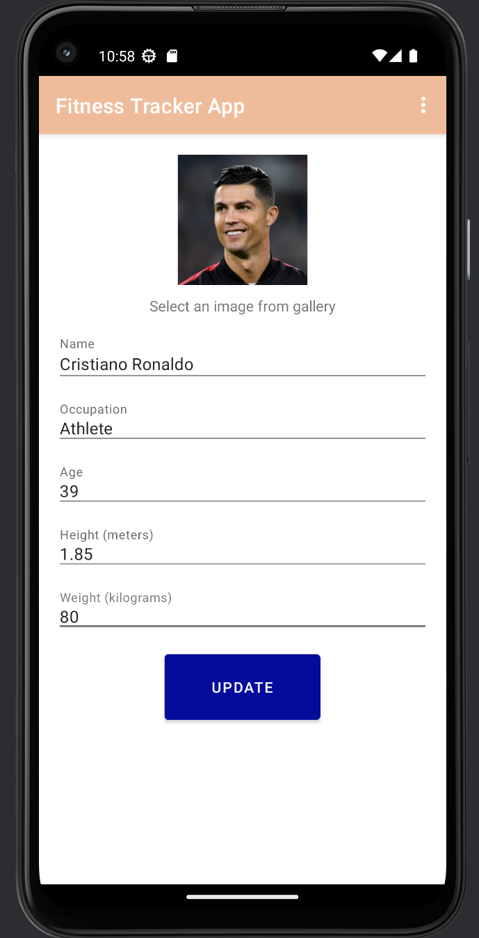

# Level 3: Extended research evidence

# References